**RSE**

***The Critical Thinking workshop*** *held in Kings Avenue encouraged our* children to **think**:

* How their opinions are formed
* Where they get their information from
* How believing in false information can hurt them and others
* What they can do to check their facts and treat others fairly

**Rethink:**

* How everyone has different opinions and world views
* How information might sometimes not be reliable
* Where they can get reliable information from
* How believing in false information can hurt them and others

**Check out our RSE Enrichment**

**Workshops!**



**Are you staying safe on the street?**

Year 3 children have received a pedestrian training which included:

* Finding a safe place to cross
* The correct use of pedestrian crossings
* Crossing at junctions or near parked cars
* -The dangers of playing near the road
* -The importance of wearing bright clothing
* -The dangers associated with being
* distracted using mobile phones and
* headphones.

|  |  |  |
| --- | --- | --- |
| Class | Spring 1 | Spring 2 |
| 1J | Secrets and keeping safe;  Recognising feelings in self and others | Keeping safe around the household products; What helps keep bodies healthy |
| 2S | Respecting similarities and differences; appropriate and inappropriate touch | Keeping safe in different situations; Healthy choices; different feelings; |
| 3A | Healthy relationships, actions affect ourselves and others, recognising feelings in others | Basic emergency aid school rules on health and safety; What makes a balanced diet; |
| 4B & 3/4H | Acceptable and unacceptable physical contact; keeping something confidential or secret | How to keep safe online, drugs common to everyday life |
| 5B & 5W | Actions have consequences; responding to feelings in others | Online safety; what positively and negatively affects health and wellbeing; |
| 6M & 6C | Different relationships; acceptable and unacceptable physical touch; when to break a confidence | keeping safe;   risks and effects of drugs |

How do gangs operate?

In our school, we make sure that our children are able to recognise dangerous situations and know how to act to keep themselves safe.

Year 5 and 6 children participated in an interactive workshop that taught them refusal skills and built awareness of negative pressure. Emphasis was placed on the differences between being “friends” and being “friendly”. The aim of the workshop was to help young people read the signs of gang membership, recognise how gangs recruit and understand the manipulative and coercive nature of gangs and gang members.



**School councillors, what’s the verdict?**

The school councillors take an active part in our school life. They tasted a few desserts and decided which cake would appear on the school menu.

 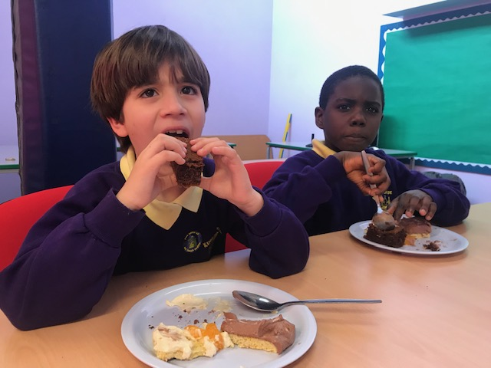 

Are they friends or just friendly?

Does my voice count?

Our school councillors meet on a regular basis and suggest how we could improve our school. They have a chance to discuss their ideas in class and vote for the ones they think will be the most beneficial for everyone at school.

**No matter how small you are, your voice**

**counts!**