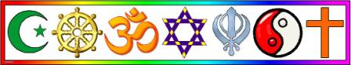

**Religious Education**

Enrichment

|  |
| --- |
| At Kings Avenue, we enhance our Religious Education curriculum with visits and visitors. This enables us to get first-hand experience of different religions and deepen our knowledge and understanding of beliefs and practices. In doing so, we nurture the Spiritual, Moral, Social and Culture (SMSC) development and the British Values. |

|  |
| --- |
| http://3.bp.blogspot.com/_QrJrqfzxTYs/SzkAhtYRtQI/AAAAAAAAAaM/2wAI4phPl-E/s400/brhats+sannyasa+2.jpg http://4.bp.blogspot.com/-0xd1RLoruZY/TWN2V2QfnpI/AAAAAAAAAUY/LB7cDK84uZo/s1600/2000px-Om.svg.png  https://www.primaryworks.co.uk/wp-content/uploads/2017/07/Slide1-16-600x450.jpg Nabhi from the Shree Ghanapathy Temple in Wimbledon, delivered an assembly to the whole school on the Hindu festival of light called Diwali. Children took part in acting out the story of Rama and Sita and learnt the Hare Krishna song. |

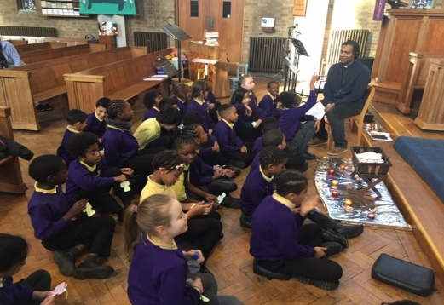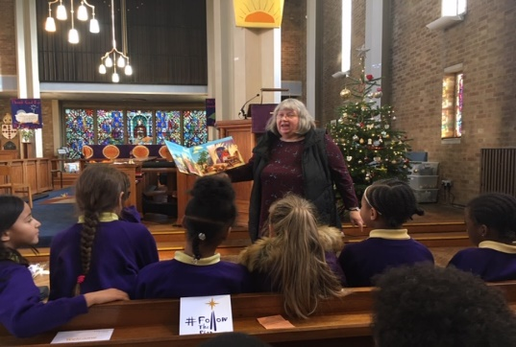

|  |
| --- |
| http://www.clipartkid.com/images/762/wooden-cross-clipart-cliparthut-free-clipart-WdFV4G-clipart.jpghttp://s0.geograph.org.uk/photos/02/90/029065_e291fca3.jpg  In December classes visited St. James’ Church to explore the meaning of Christmas for Christians. They had the opportunity to take part in group activities, discussions and story telling sessions with Reverand Kit and his team. |